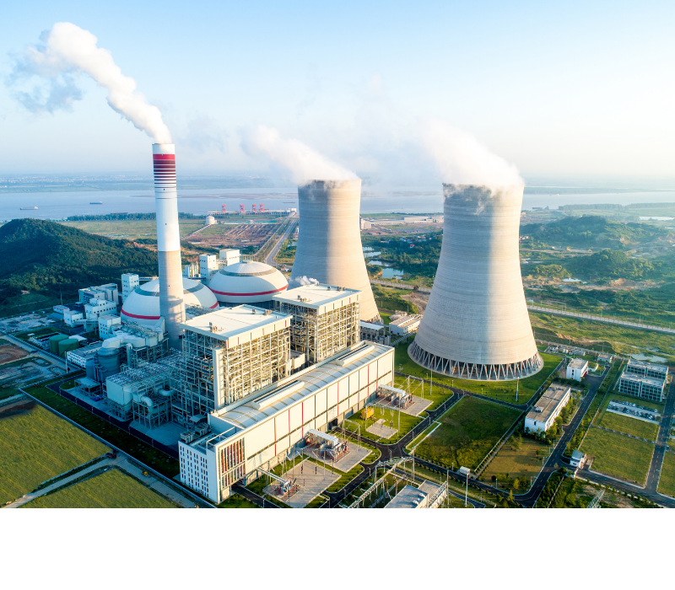

**What is The Filtration Application in Power Plant Boiler System?**

The three main equipment of the power plant are composed of boiler system, steam turbine system, and generator system. The state requires power plants to achieve zero emissions of pollutants, so that the emissions treatment of power plants should be higher, and at the same time, it also expands the market for filtration equipment.

In addition, the power plant water treatment system is also a complex treatment system. Power plant water is generally required to be recycled and reused, and water filtration treatment also requires many different filtration equipment.

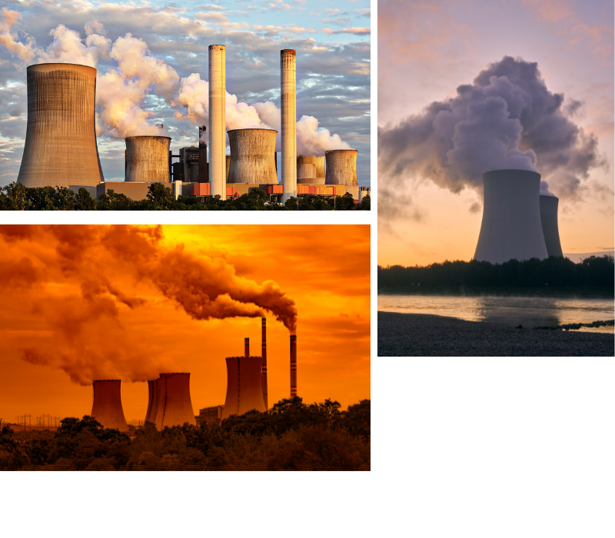Let's take a look at the following filtration application in boiler system of the power plant:

**Boiler System**

The boiler is one of the three main engines of the power plant and the heart of the thermal power plant. There are cycles through the boiler system: pulverized coal is burned to become coal ash and discharged; water is transformed into steam through the boiler and sent to the steam turbine; air is mixed into soot through the boiler.

**Boiler Water**

The boiler supply water is mainly provided by an electric feed water pump. The main process is:

The sludge discharge from the bottom of the clarification tank is concentrated in the thickening tank and sent to the sludge dehydrator for dehydration, and the mud cake is transported to the dry ash yard for storage. The clean water is returned to the wastewater storage tank, and a large number of water filter elements are used in the process, such as [String Wound Filters](https://www.hongtekfiltration.com/string-wound-cartridges/), melt blown cartridge filters, [Pleated Filter Cartridges](https://www.hongtekfiltration.com/pleated-cartridge-filters/) etc.



**Boiler Burning Coal**

The coal of the boiler is sent into the furnace by the primary fan, and burn into coal ash under the combustion of the secondary fan. The turbidity in the superheated air enters the dust filter under the negative pressure generated by the induced draft. Before the coal enters the furnace, some limestone coal will be mixed to absorb the sulphide after the coal is burned, and reduce the pollution of the flue gas. The ash and sulfuric filter mainly use filter bags, which has different models and are widely used in power plant.

The power plant is a huge system, and a small internal system is relatively complicated. The filters used involve oil filtration, air filtration, and water filtration, and the amount of use is quite large. Non-standard parts will be encountered in the use of power plant filter elements, and on-site surveying and mapping are required to determine the model and size.